Events Unknown by Ashtyn Ellis
Events Unknown is a survival, psychological horror game where the protagonist Michael is having a picnic with his family when they are attacked by strangers. Michael wakes up to see his wife stabbed to death and his daughter, Sophia, missing. He follows clues to get to his daughter while avoiding goons and hunter traps along the way. While he explores the woods, he seems to recognize some things such as areas, items, and even comes across his own watch along the way, maybe Sophia had it with her this whole time? Or has Michael been here before?
Genre: psychological horror. It’s a category of horror that focuses on mental, emotional, and psychological states to disturb the player. Some similar games in this genre include: The Medium, From the Darkness, and even Little Nightmares 1 and 2.
Mechanics: Visuals are typically dark colors, not much lighting to give a melancholier affect. Walking and crouching animations for Michael as well as animations when he picks up a note or other items.
Story: Michael and his family were having a picnic when they were attacked. Michael was knocked unconscious and when he awoke, he found his wife stabbed to death and the footprints of Sophia leading to the woods. He must find his only family left and escape however, there’s something strange about the woods Michael must travel through. He comes across clues of Sophia via pages from her diary as well as notes from mysterious people. When Michael finally finds his daughter in a creepy abandoned shack, she refuses to leave with him. After he tries to convince her she holds up a knife she found to her father and tells Michael he was the one who killed her mom. Michael is confused and tells her it’s nonsense. Players then are brought through flashbacks where we do in fact find out that Michael did kill his wife, Jane. He just doesn’t recall this and convinced himself that they were attacked, and he imagined the traps and goons in the woods along the way as well. The notes that the player collects turn out to be from Michael’s victims that he has tortured and killed before in the very shack they are in.
Character Descriptions: Michael Yates, an early 40’s husband to Jane Yates and father of Sophia Yates. He’s an alcoholic who shows symptoms of schizoaffective disorder. He is often very groggy and annoyed at the world, except to his daughter. He claims he is incapable of harming another person, although his past actions say otherwise. Overall, he isn’t quite a reliable narrator when it comes to his past. His only motivation in life is trying to give Sophia a good life although he is stolen away from her due to his drinking and smoking habits. Appearance: 6’0, unkept apparel, grey hair, stubble beard, green eyes.
Sophia Yates, a young 12-year-old girl who has some anxiety disorders. She’s a very shy girl who loves to read and loves to be with her family. She doesn’t believe she is capable of anything, but she is stronger than she realizes after what she’s been through. Her desire is to become a doctor one day to help others and is motivated by the thought of being able to help others. Appearance: 4’3, brown hair, green eyes, slightly red cheeks.
Jane Yates, early 30’s, wife to Michael and mother of Sophia. She’s very reserved and doesn’t react emotionally to anything but she is happy when with Sophia. She’s a stay at home mom who doesn’t like to leave the house anyway. She got pregnant with Sophia at 17 and married Michal after she turned 20. Appearance: 5’2, brown hair, blue eyes, freckles.
Setting: Beginning in a open park where they have a picnic led to a very wooded area, mossy trees, ponds, rivers, as well as a scene in an old abandoned shack where we find Sophia.
Target Audience: Mature at least 16+ due to dark topics and blood.
Levels: The world is ordinary on Earth, there is a large park where it takes place as well as a large wooded area where the player will explore. The woods are very dark and dreary compared to the park area. Hazard wise, the player will come across enemies with guns and knives he must hide from their vision and sneak past them. There are also some bear traps to avoid as well as other animal capturing devices. His only goal is to avoid detection and find Sophia while collecting lost items and notes along the way.
UI: When the cutscene ends in the beginning a menu will pop up describing what/where everything is as well as explain what keys do what (A moves left, D moves right, C is crouch, E is inventory, and Q is pick up an item). The player will have their health bar next to the characters photo in bottom right and right below that is a visibility bar that will fill up if he is spotted by an enemy, as well as their inventory in the bottom left, next to the inventory is where the player can view the notes and collectables they’ve found along the way. When the player opens inventory or notes, they’ll be able to scroll through either one as well as have other tabs such as a map, and a page for collectables found.
Concept Sketches:
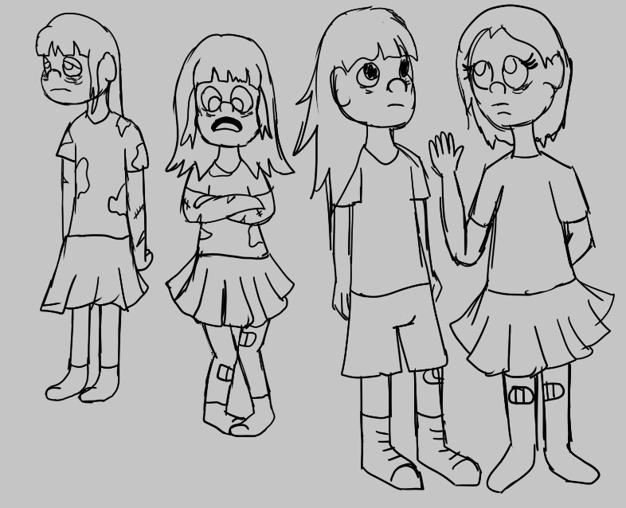

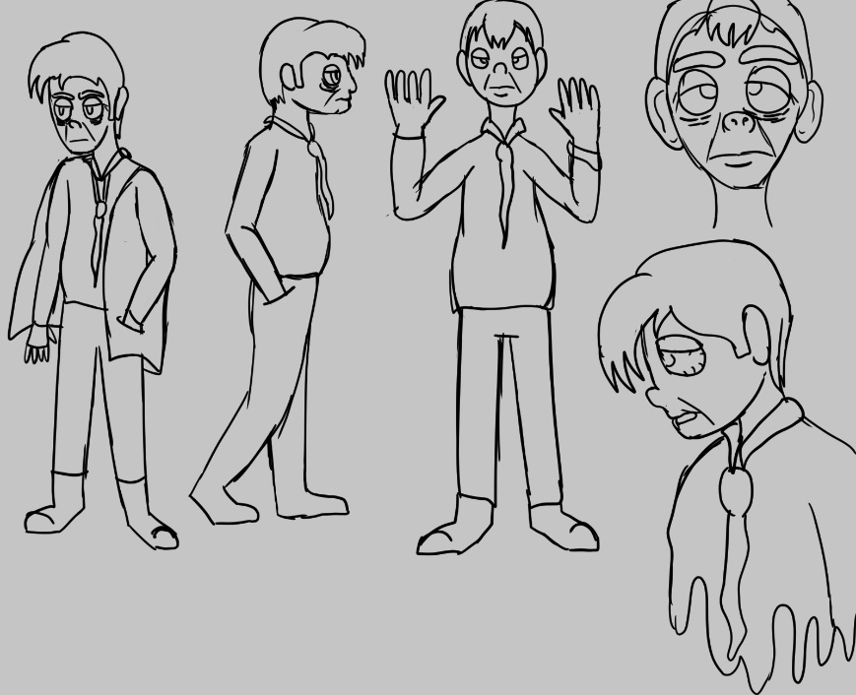

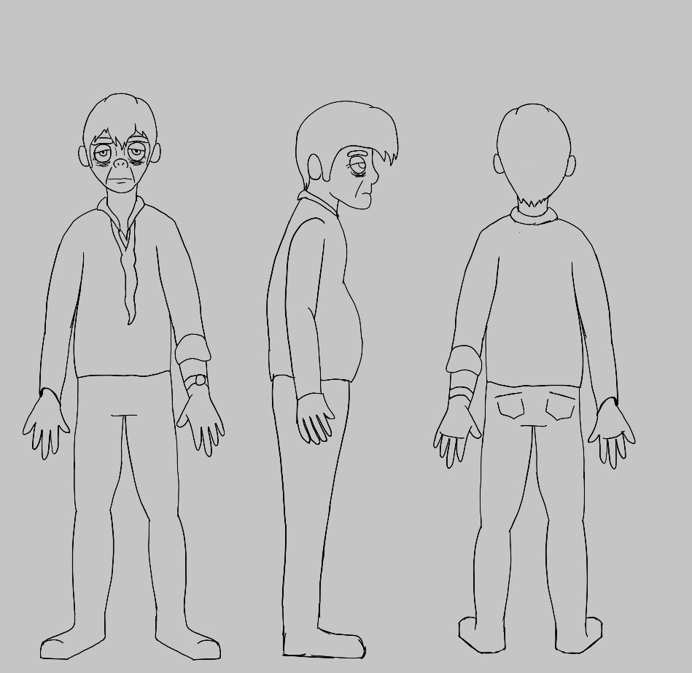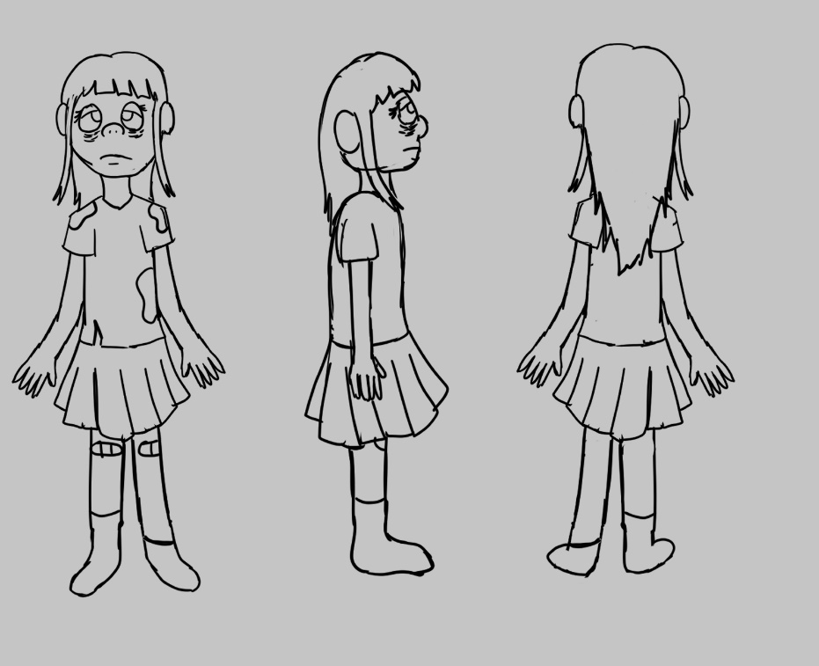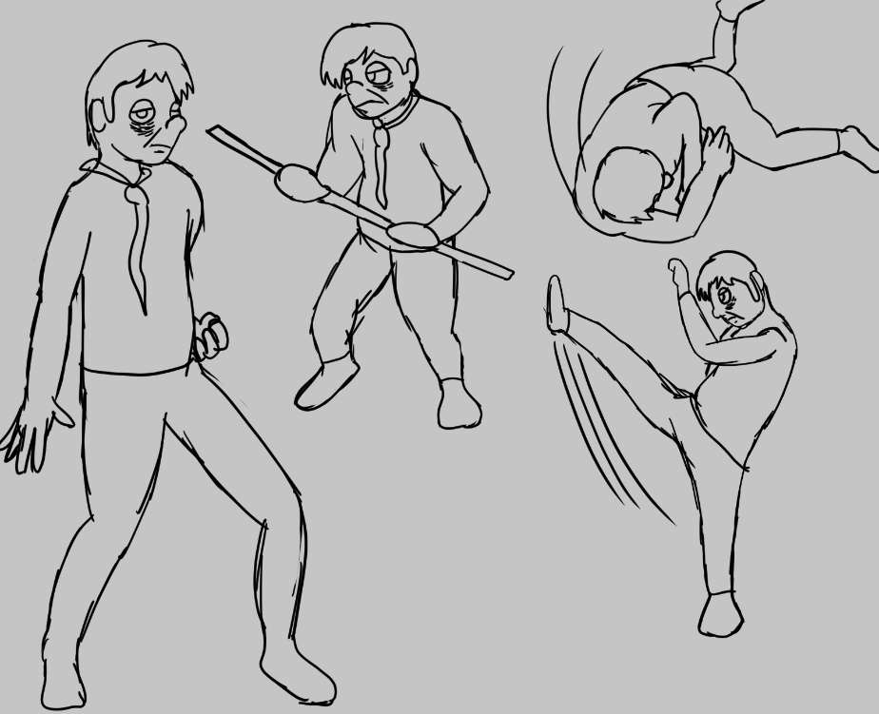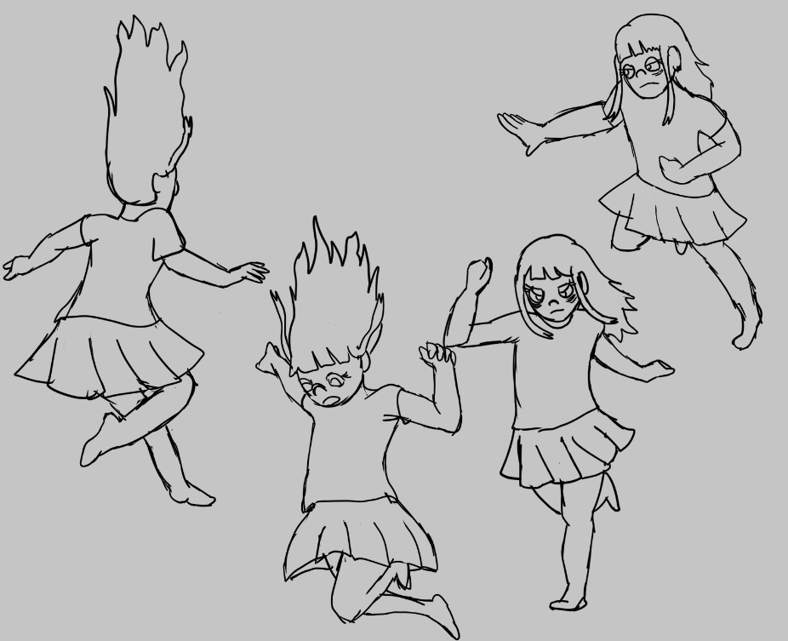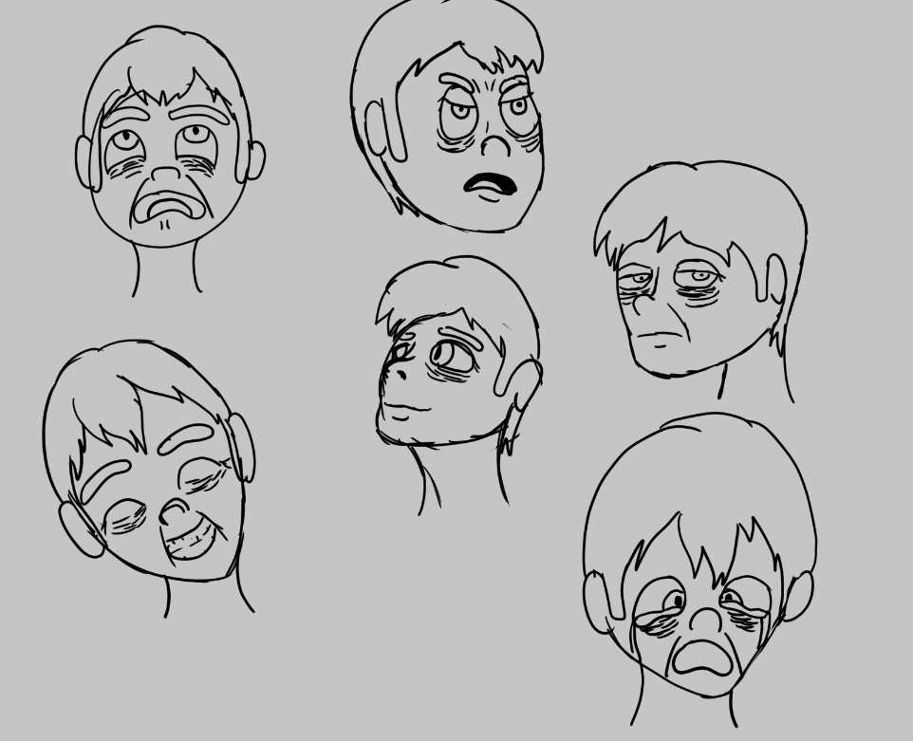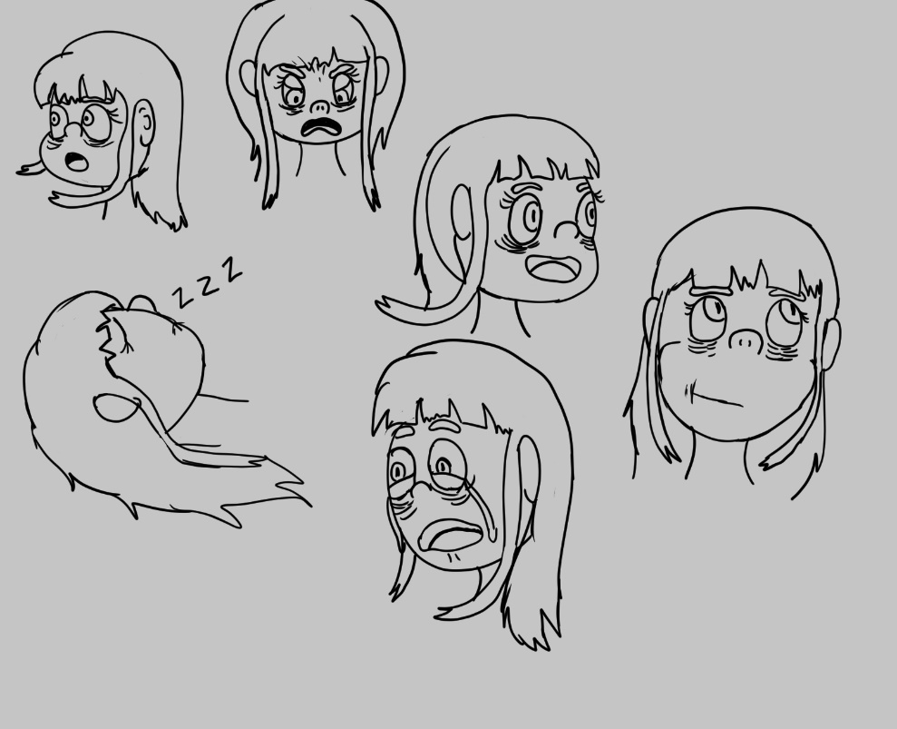

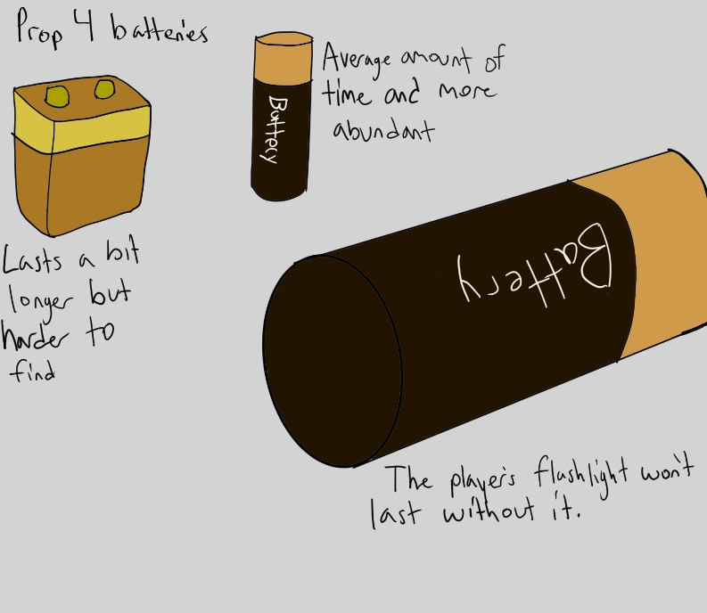
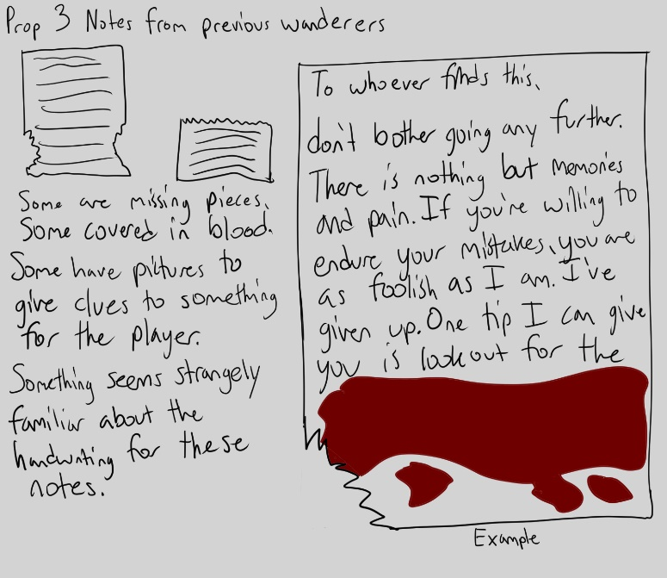
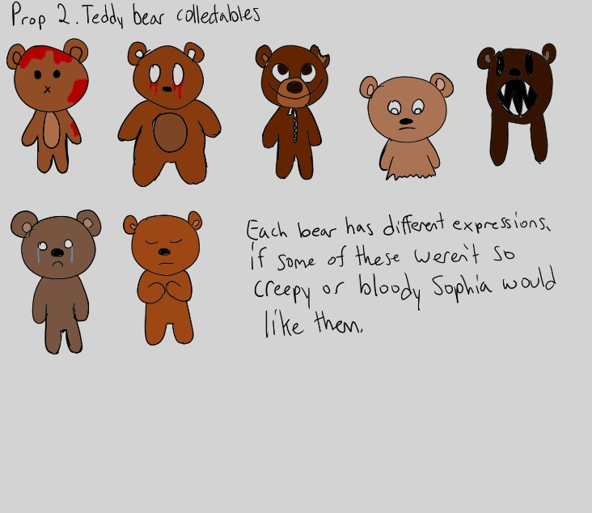
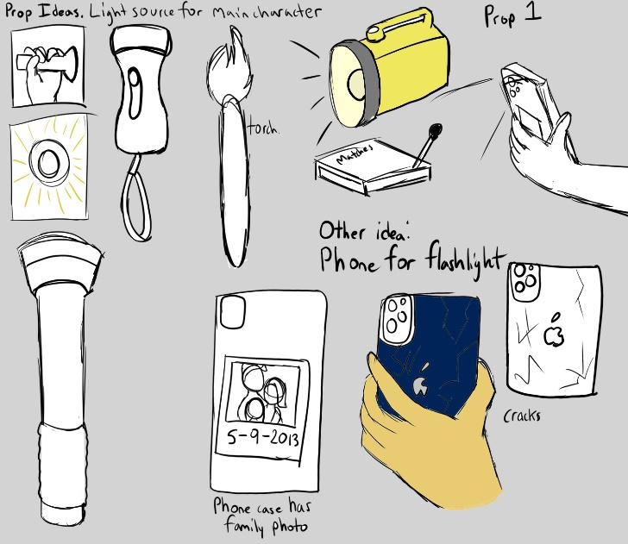

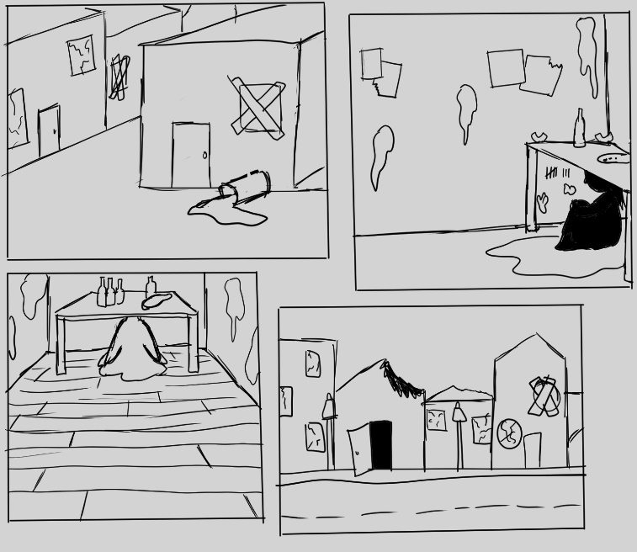
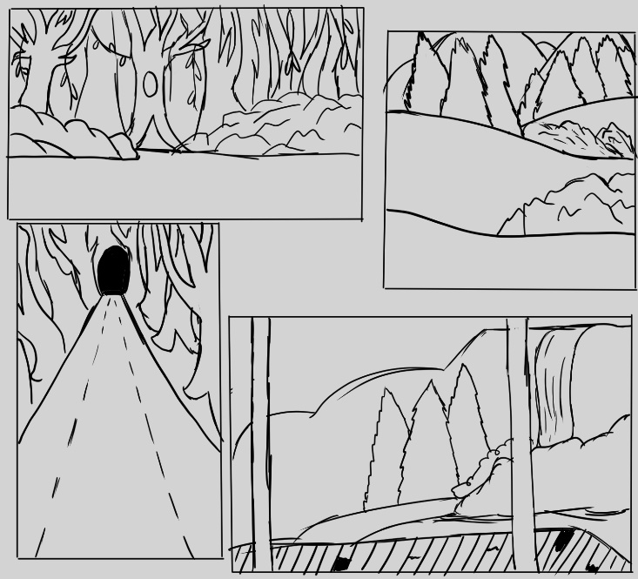
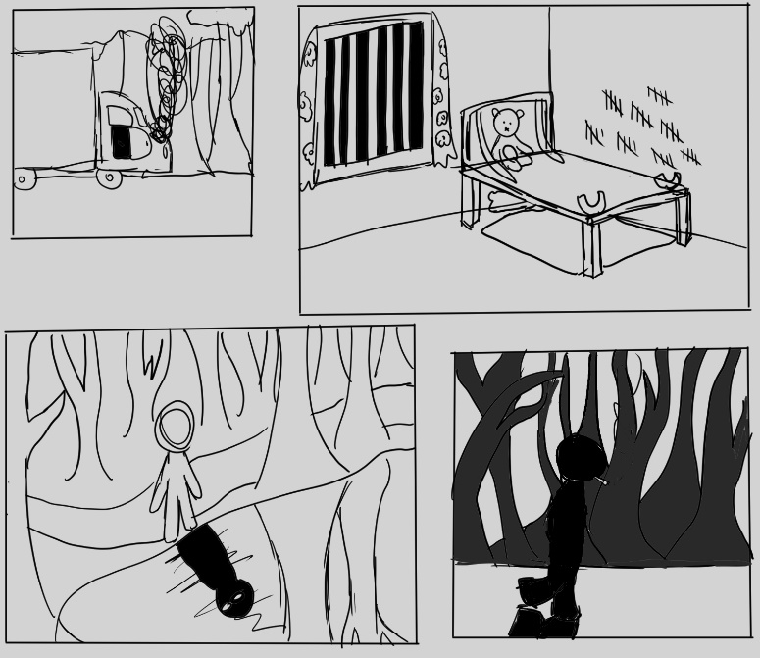
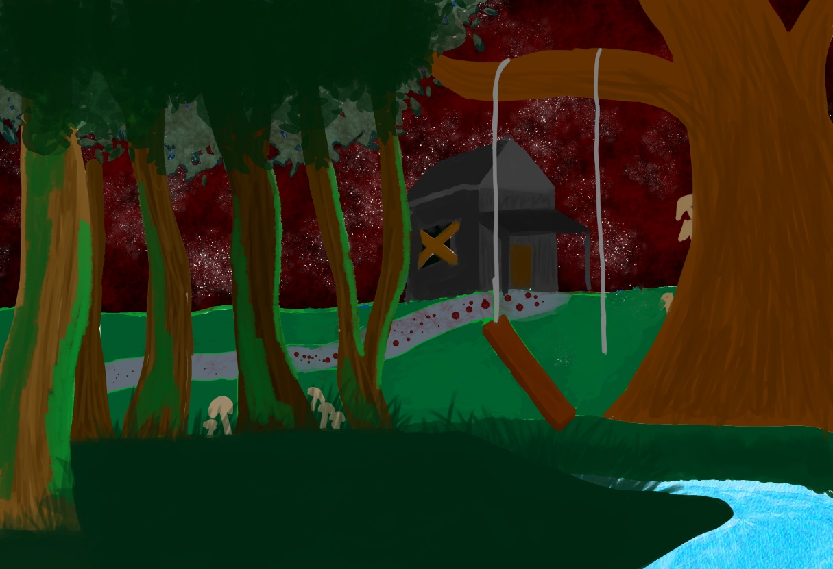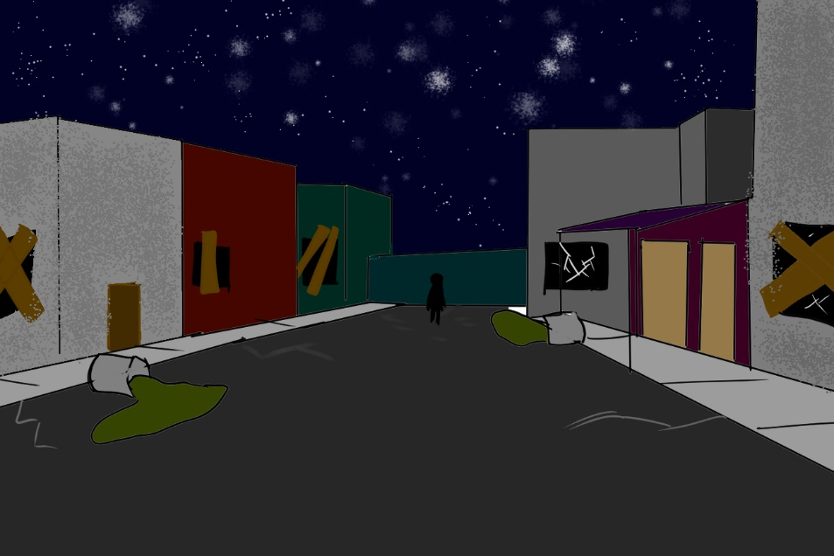

UI sketches
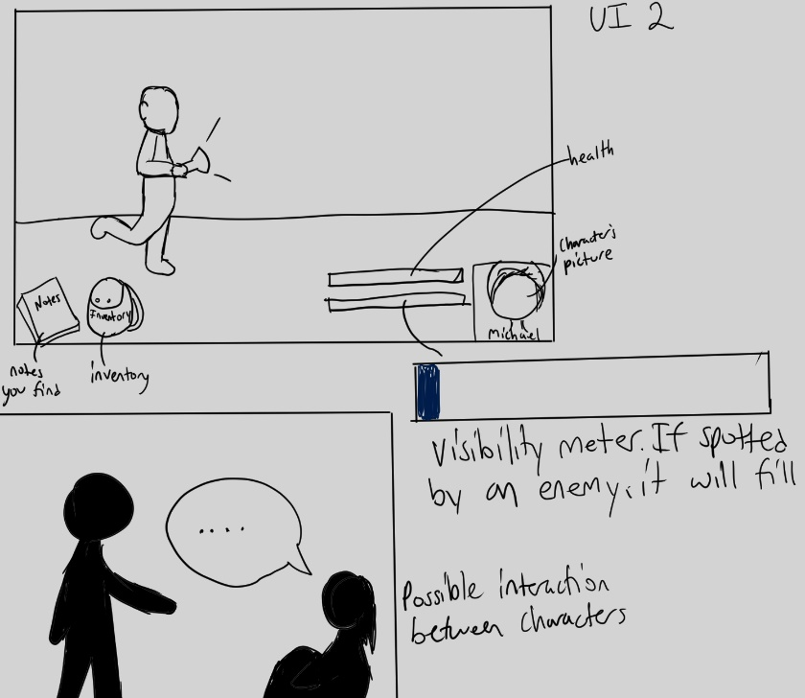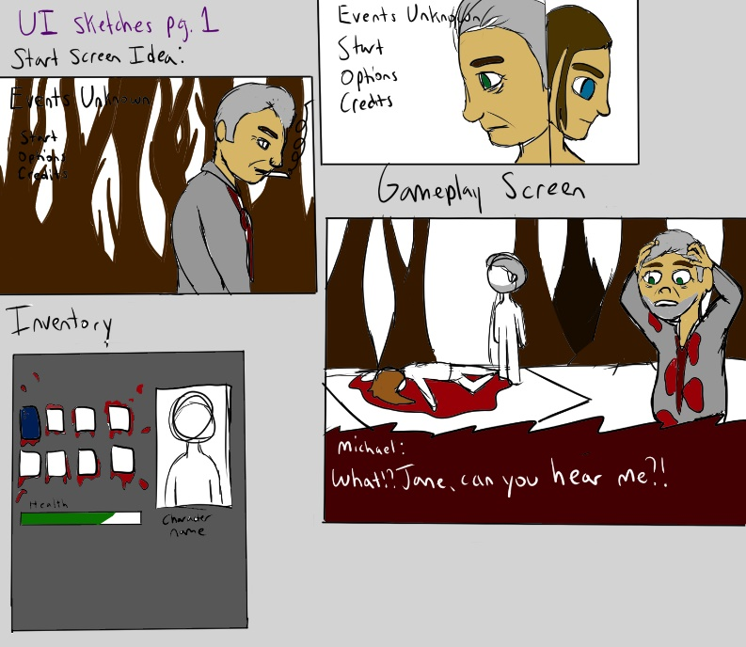

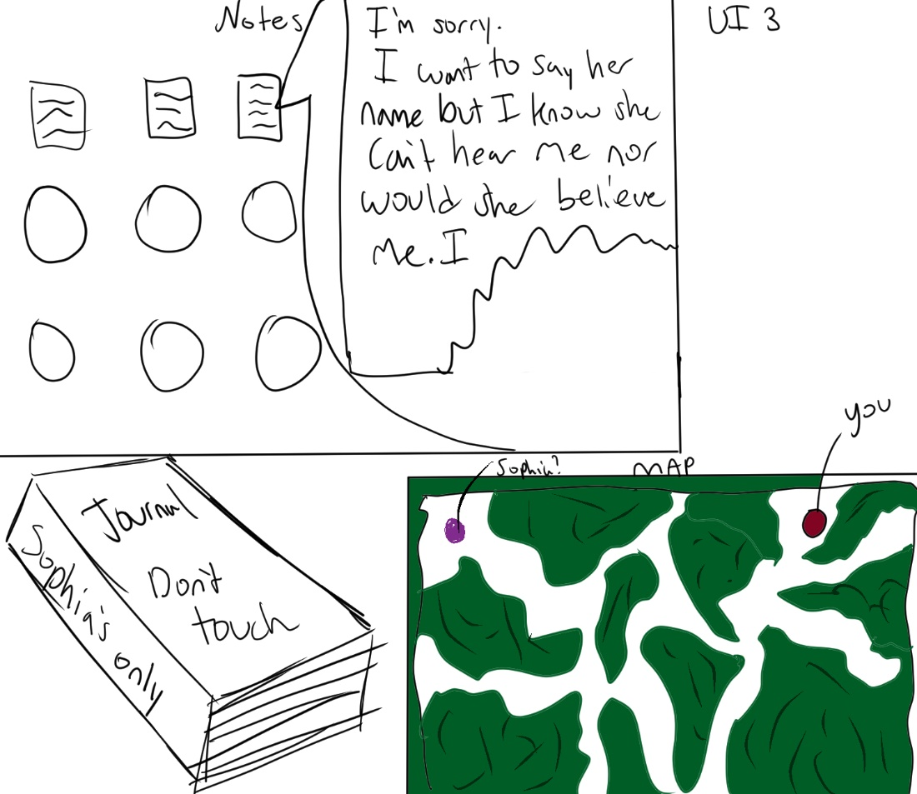
UI sketches continued:

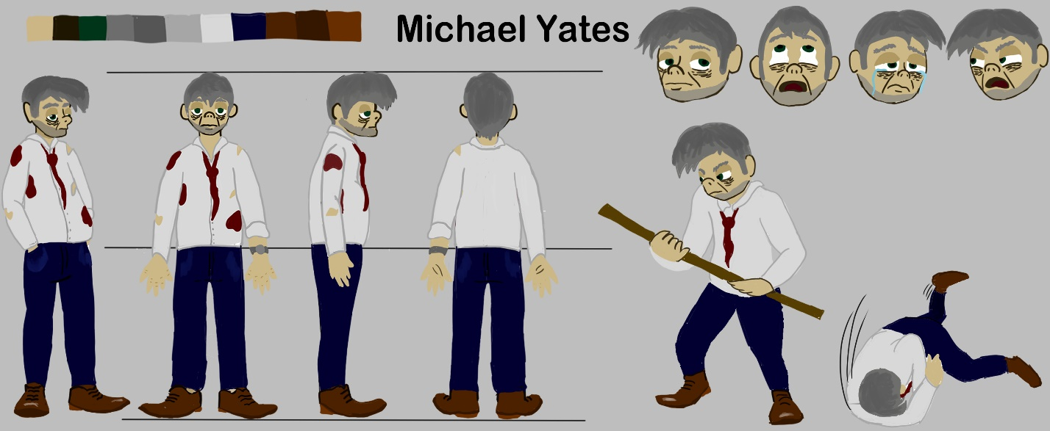
Final Concept Art:
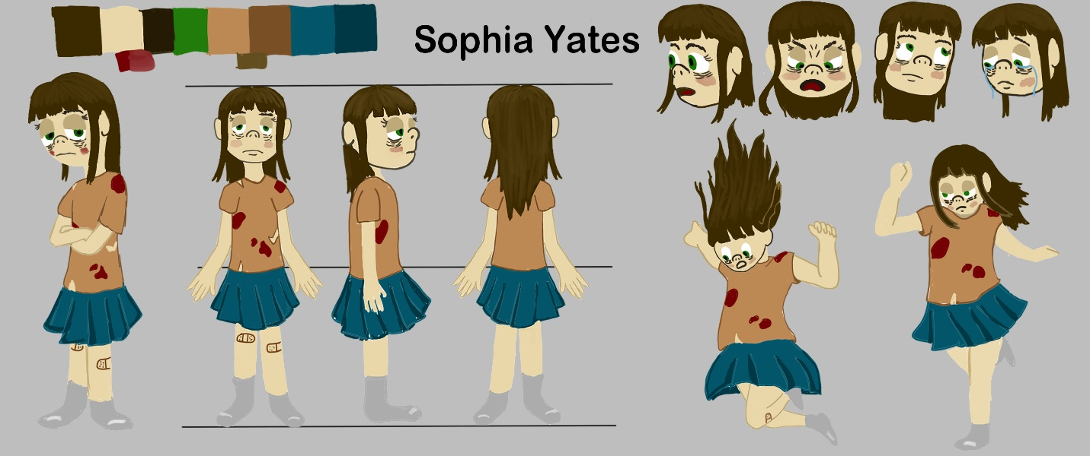
Michael Model Sheet
Sophia Model Sheet

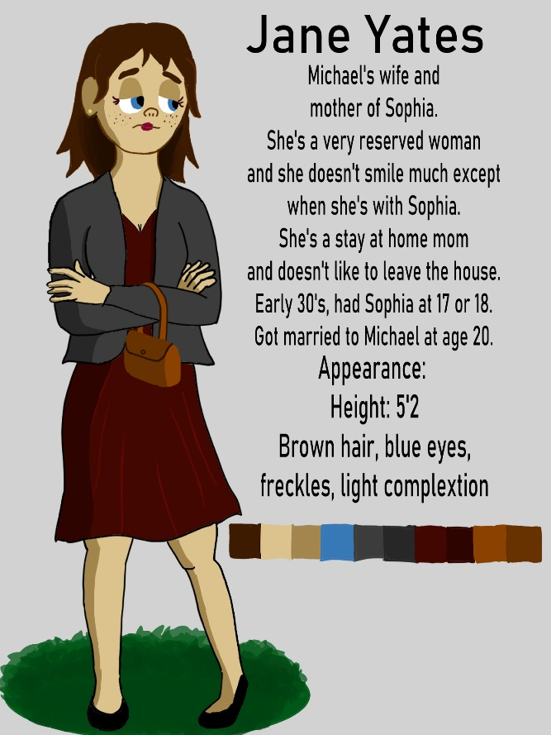
Jane Yates full color illustration
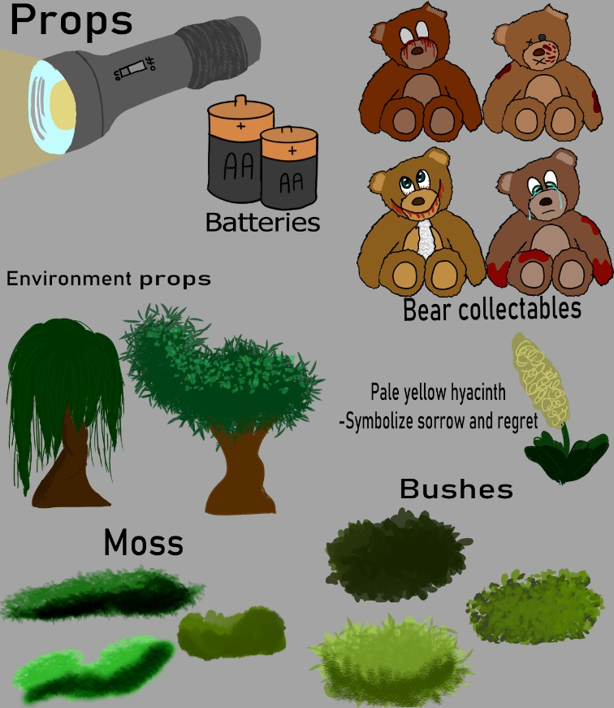

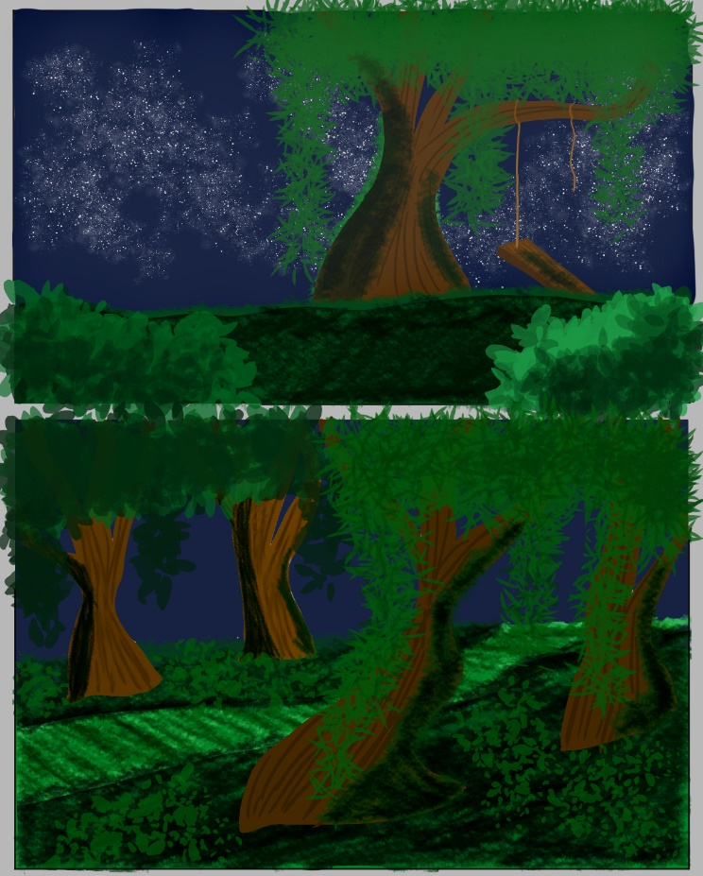

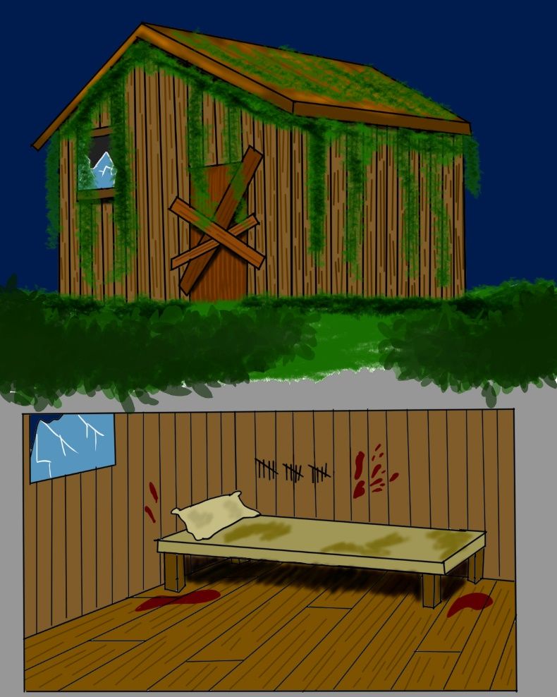

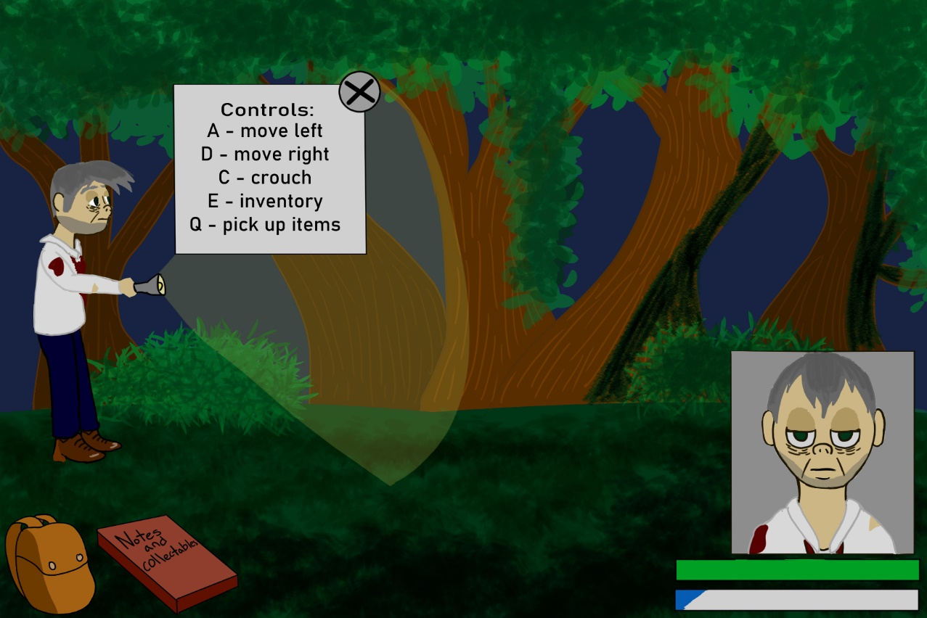
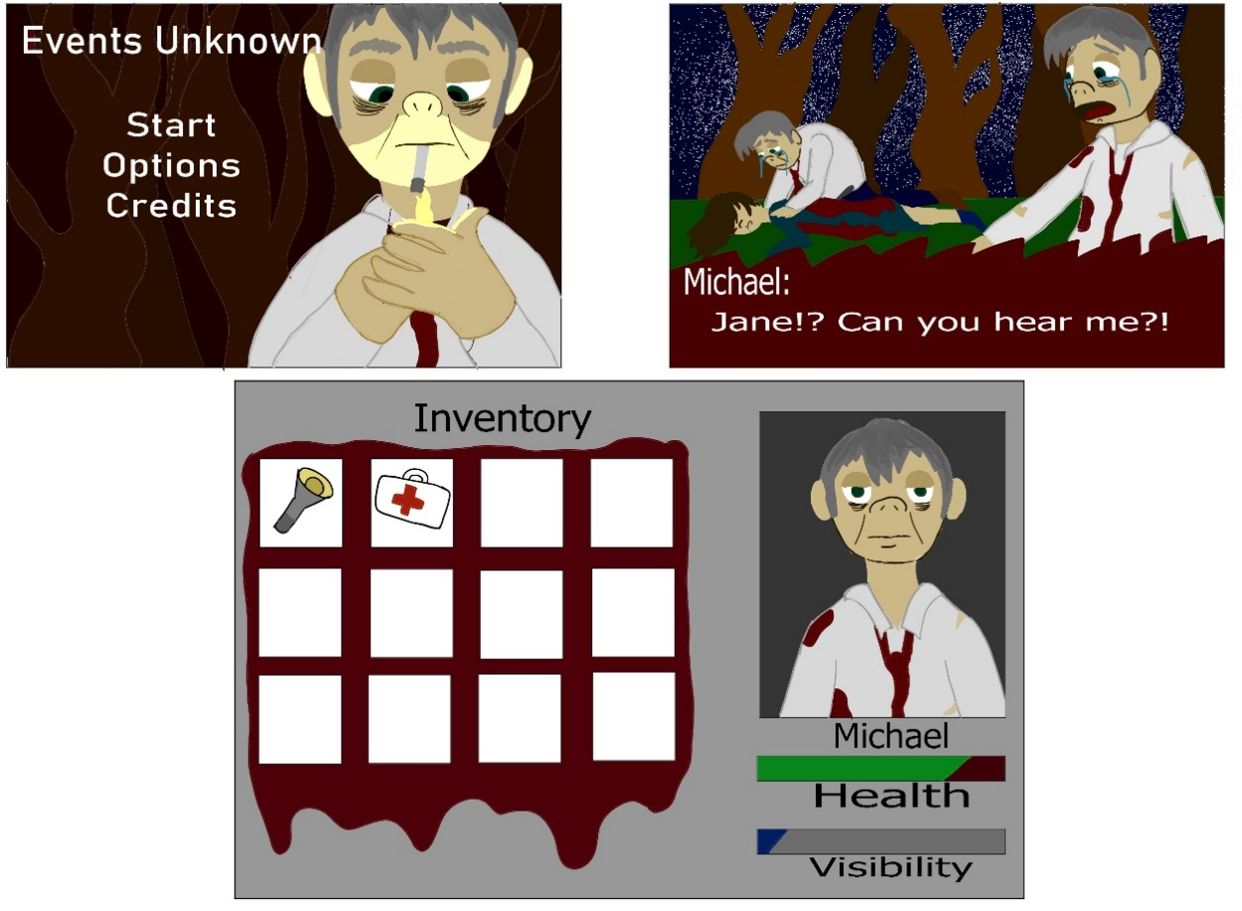
UI Model Sheet

Game “screenshot” illustration, (beginning of the game where it explains the controls).

