Magic of Gee (GDD)
Ashtyn Ellis

Table of Context
Concept 3
Genre 3
Target Audience 3
Mechanics 4
Levels 4
Story
Characters
Annabel Bloodworth (Sketches) 5-7
Goblin the Cat-Shark (Sketches) 8-10
Final Character Models 11
Environments 12-13
Props 14-15
UI 16

Concept
Magic of Gee is an open-world, 3D eerie adventure where the player views the world through a little witch girl, Annabel Bloodworth. It is told through Annabel’s perspective as she explores her Coven’s forbidden forest, searching for her broomstick before she heads off to witch academy. As she explores, she gets to learn dark secrets about the creatures that live in the woods as well as learn about her dark secrets of the coven using her trusted blanket as her tool and her weapon. She must find her broomstick before she is sent off, after all the saying goes “a witch without her broom is a witch destined for doom.”
The player uses Annabel’s blanket by turning it into tools/weapons for a short amount of time (whip, glider, invisible cloak, slingshot, etc). Each blanket ability is used for a certain puzzle or to scare away a certain enemy. There is also a flashlight but beware how much it’s used as you need to find batteries to keep it going and sometimes it can attract unwanted attention. Enemies are ghoul-like fairytale creatures that were banished to this forest. They will attack the player reducing their health and if it reaches 0, they must restart at their most recent save spot. Sometimes there will be NPCs the player can interact with; they could help, it could be a trap, or even ask for the player’s help. On this adventure, the player can learn dark secrets about the character’s coven, maybe it’s enough for the player to decide to never return home. And begin to question, are these creatures the bad guys?

Genre
Magic of Gee explores the vast world as an action adventure that tells a story. It can be played on all consoles as well as PC and has similar atmosphere to “Little Nightmares” and “Lost in Random”. Similarly, there are missions the character does to progress the storyline and there are characters the player meets where they can help them or be tricked by them. The exploration is much like “Far Cry” games where there are collectables scattered around the map and secrets.
Target Audience
The story is aimed for audiences of teenager and up as it does have some dark themes and topics as the player learns more about Annabel’s “family”. It aims towards players who enjoy stories that uncover deep and dark secrets and creative character designs like “Little Nightmares” and “Lost in Random”.
Mechanics
Open World- Player explores the Coven’s island and can meet NPCs from the Coven itself and the creatures that live in the forbidden woods.
Cutscenes- develop the story and give players a break from exploration. Get to see how Annabel’s character changes mentally and emotionally throughout the story.
Inventory- The player can collect ingredients for potions, and oil for the lantern to see.
Collectables- Player can find letters and notes that entail more information about her Coven’s members.
Combat- Using Annabel’s blanket, you can fight enemies off by turning it into different types of weapons.
Levels
Level 1 Bedroom/Home- Story starts in Annabel’s home, where we meet her “mother” and “sister”, we get hints that Annabel is in a troubled home and see her family’s personalities come out. In the middle of the night Annabel must sneak out of her house to search for her broomstick.
Level 2- Her coven’s “town”, player must sneak past other members without being seen and escapes into the woods.
Remaining Levels- Once away from the Coven the player can openly explore the rest of the island. Once the player follows the correct trail they will follow along the storyline and meet the creatures of the woods.
Ending Level- The player gets to decide between two options after learning the secrets of the coven, they can choose to return home with the broomstick before being sent to Witch Academy OR to run away from the Coven to find her real family.
Characters
Annabel Bloodworth- 13-year-old witch who lives with her “mom” and “sister” in their coven. Personality changes as the story goes, in the beginning she’s very oblivious and playful, as she learns more about her coven, she becomes more mature and self-aware.
Goblin the Cat Shark- Acts like a 1 year old playful cat, Annabel’s imaginary companion she can call on command to go through obstacles to open doors or retrieve items.

Annabel Bloodworth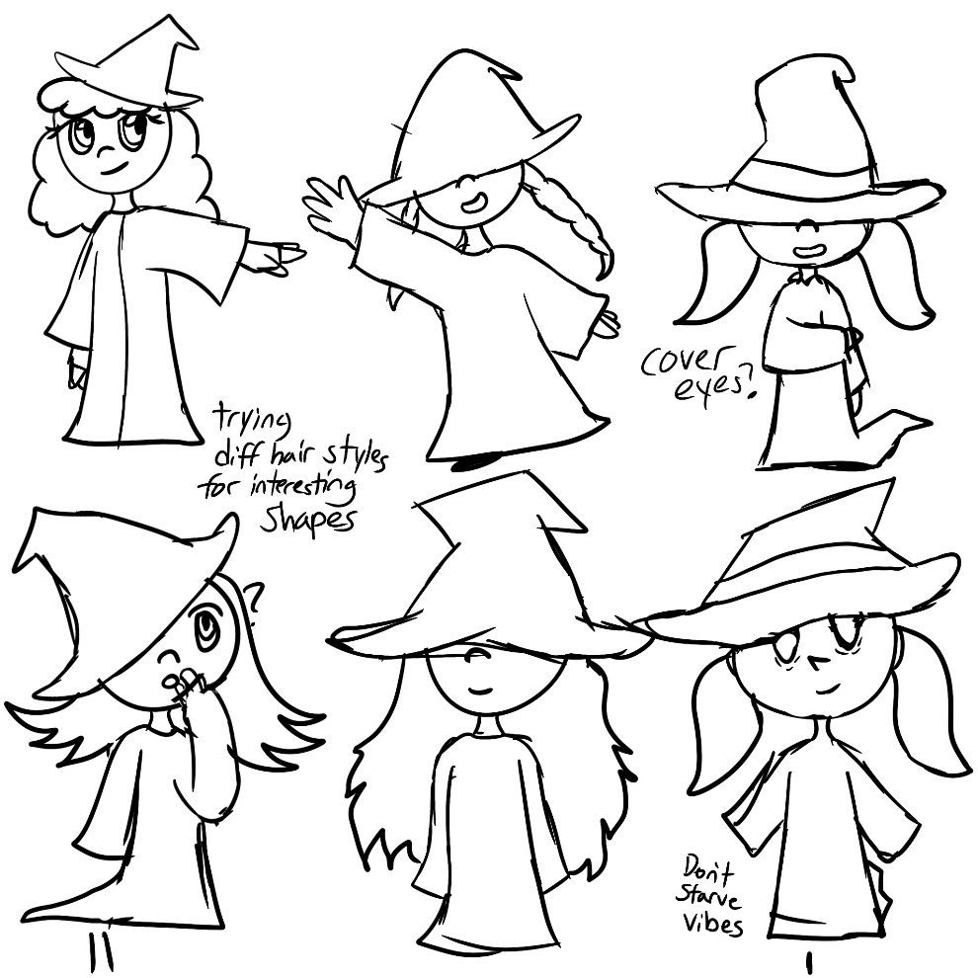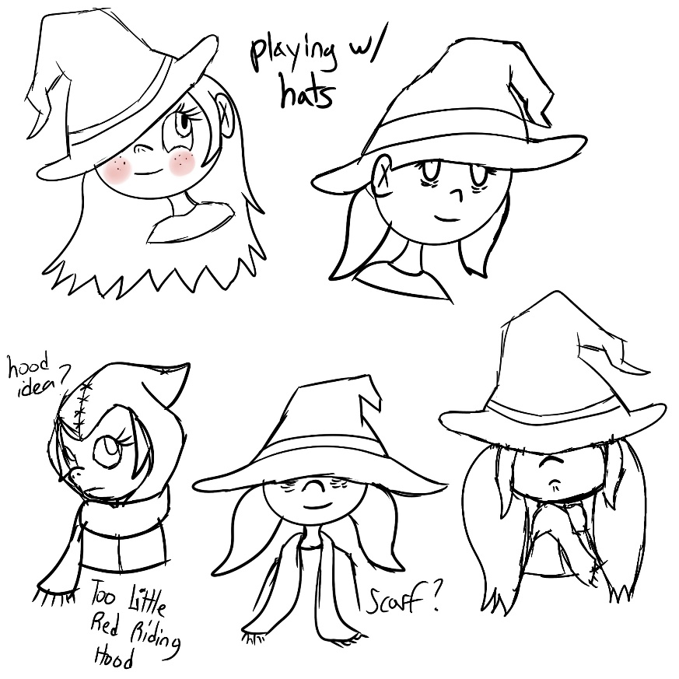
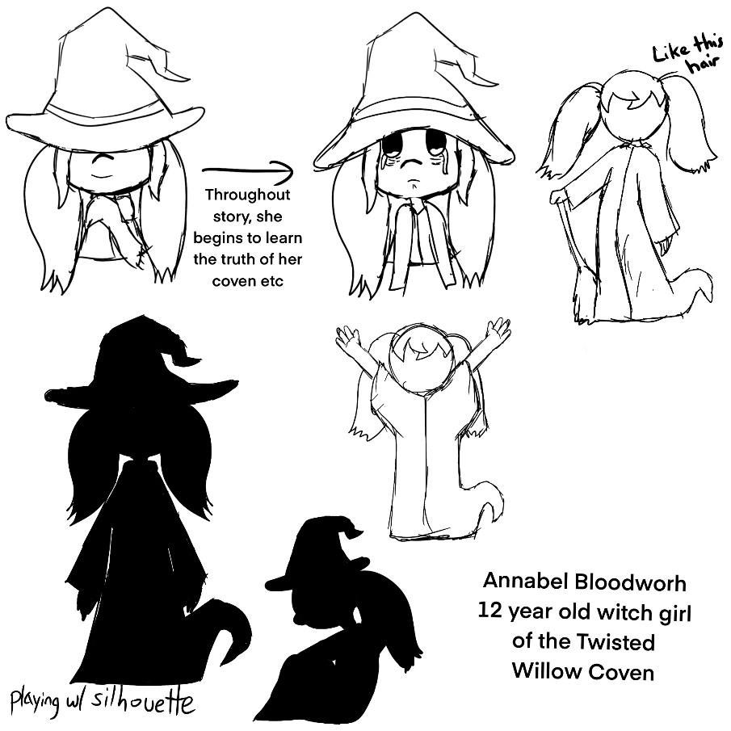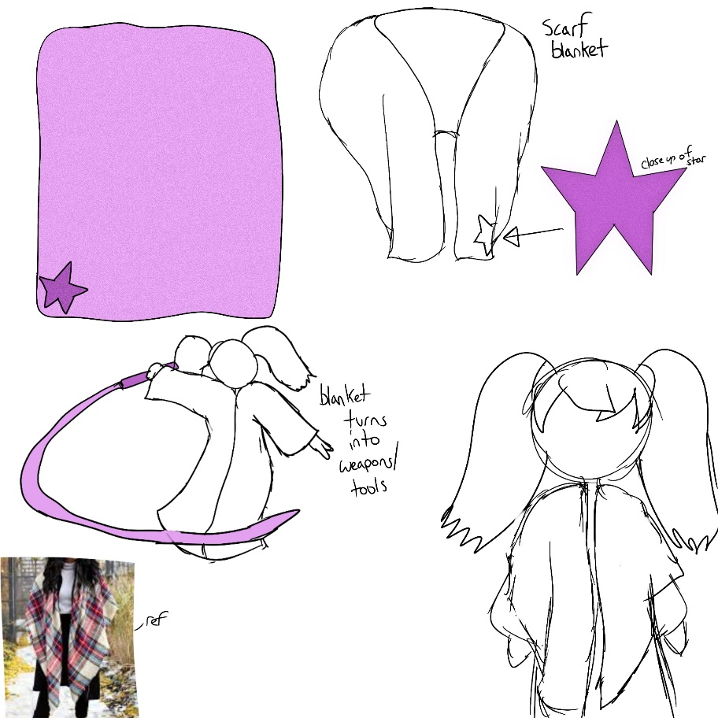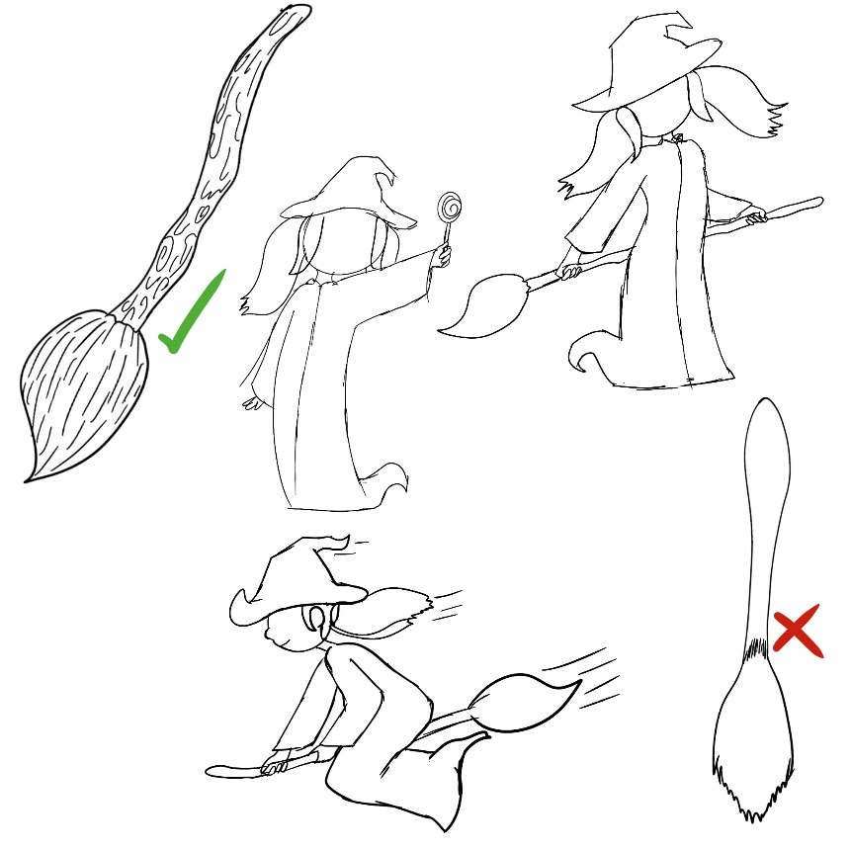

Goblin the Cat-Shark
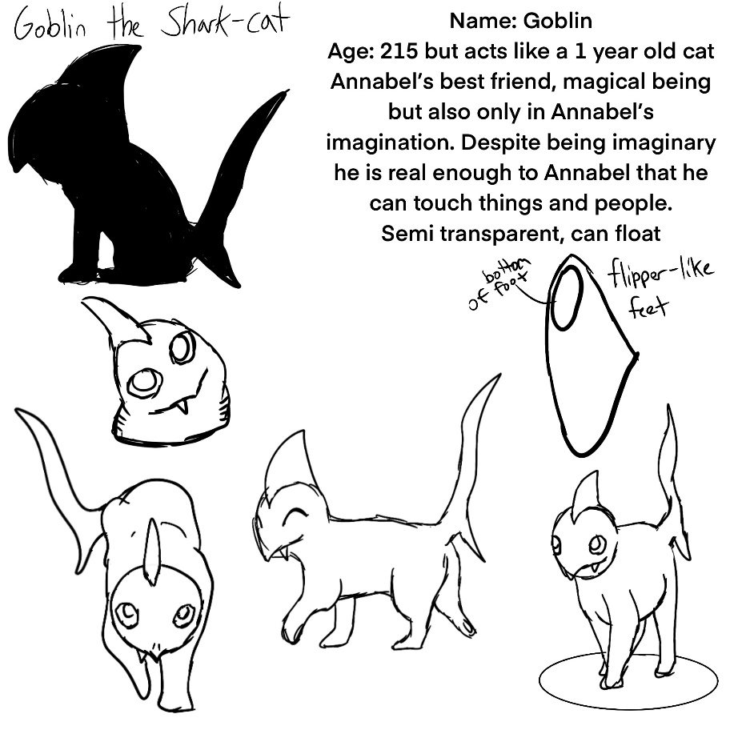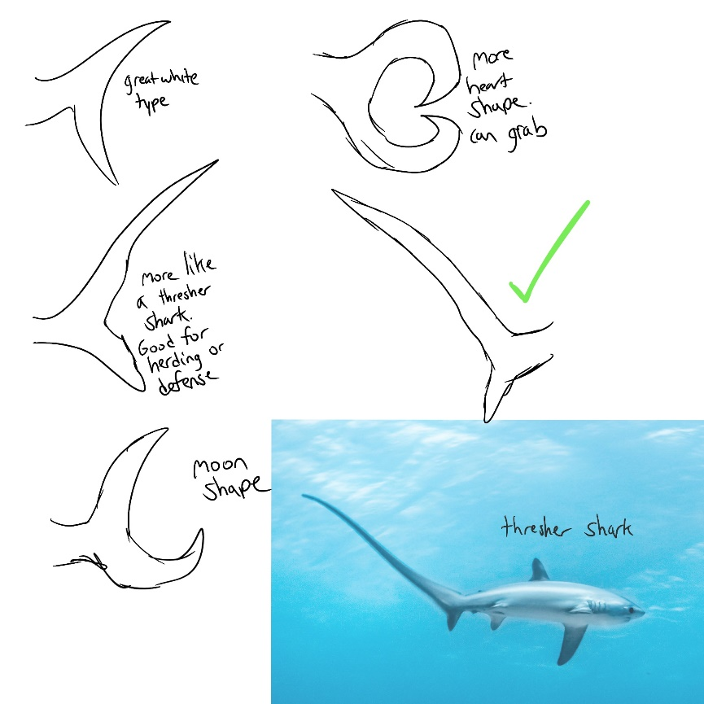
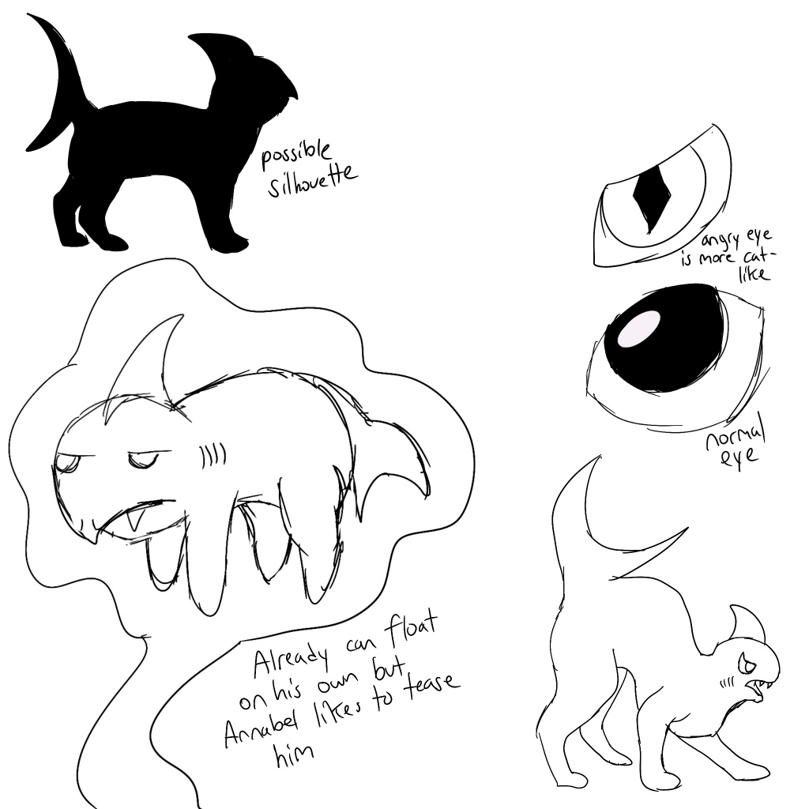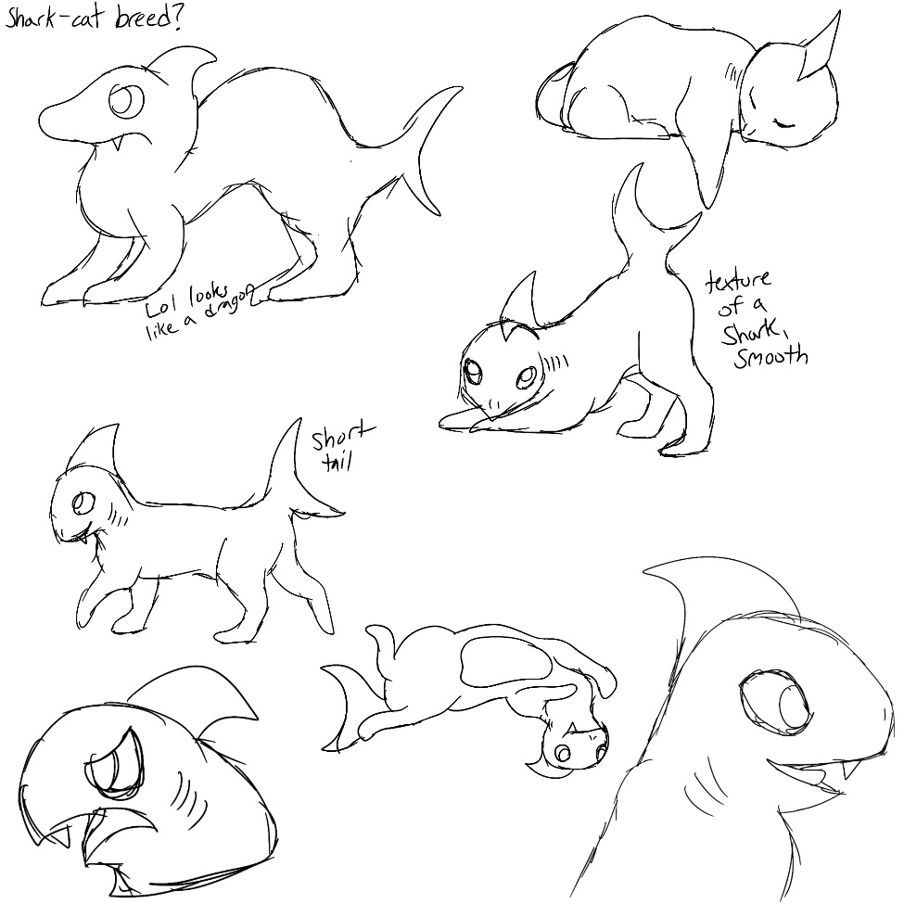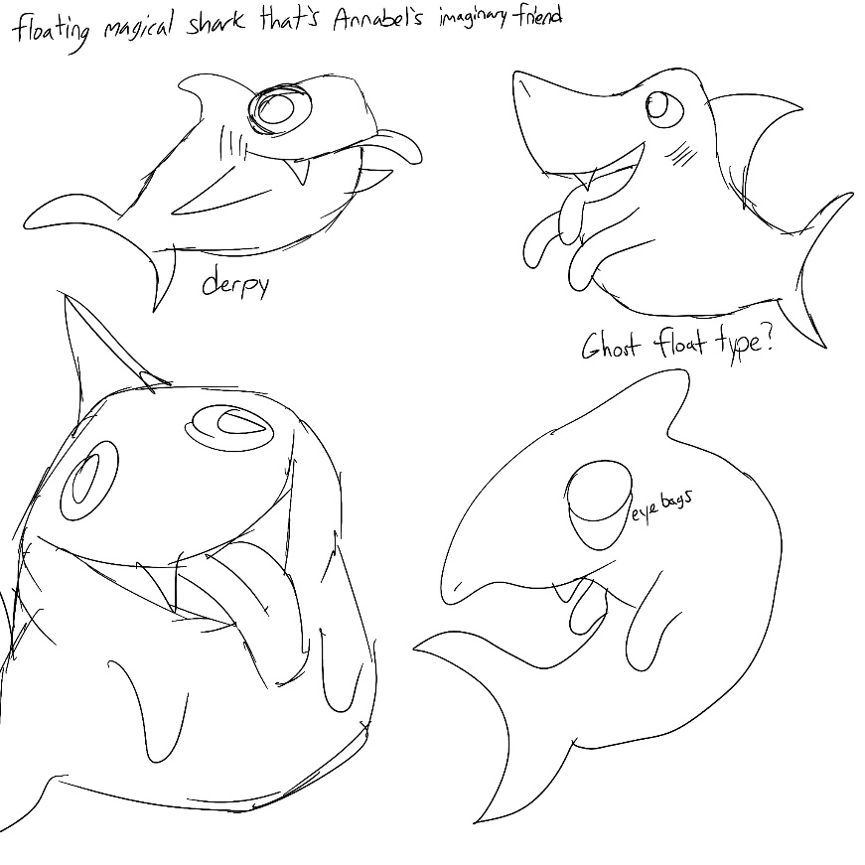

Final Character Model Sheets
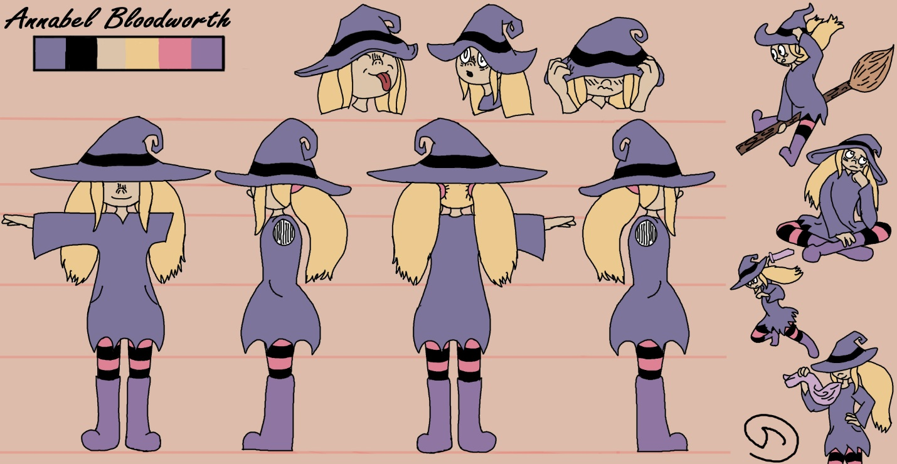

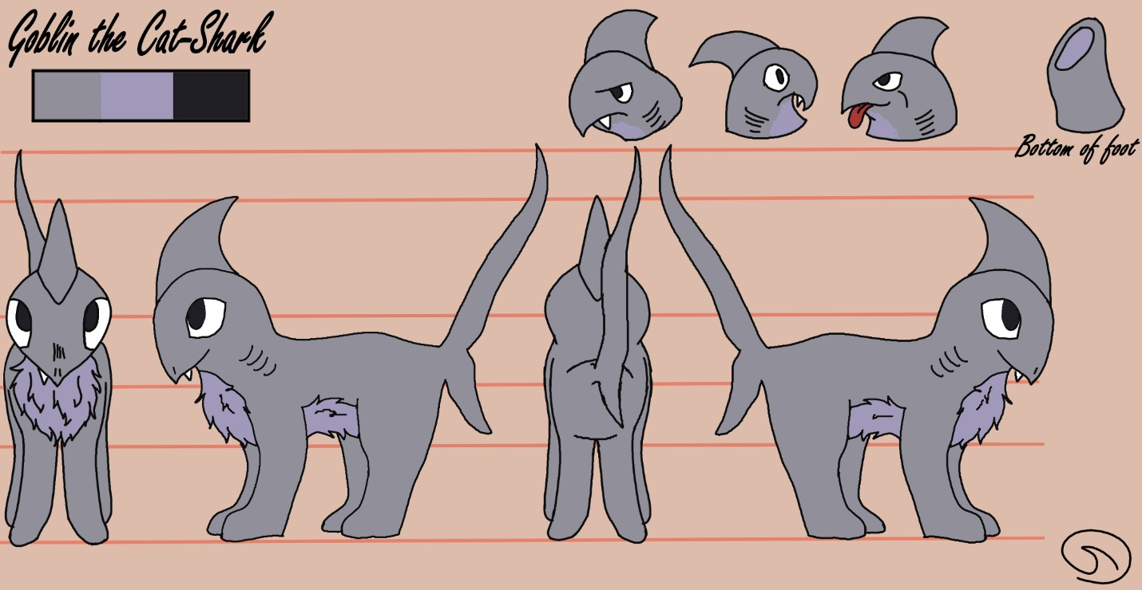

Environments
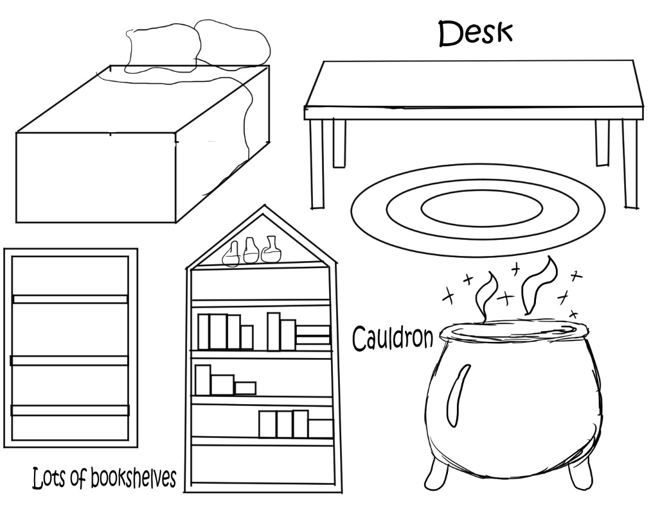
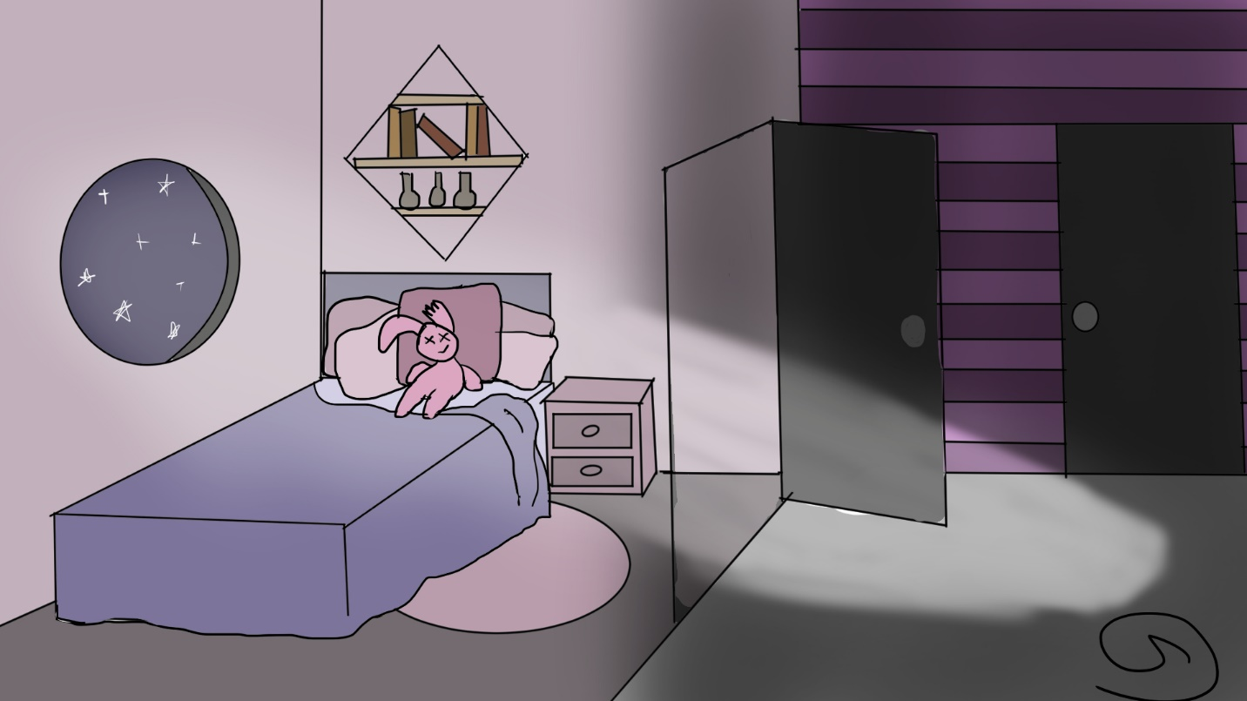

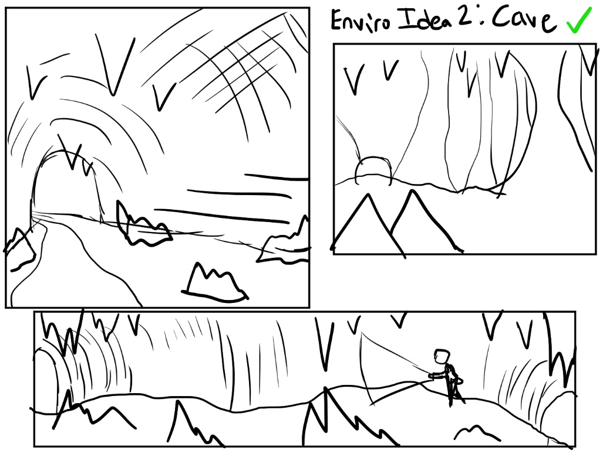

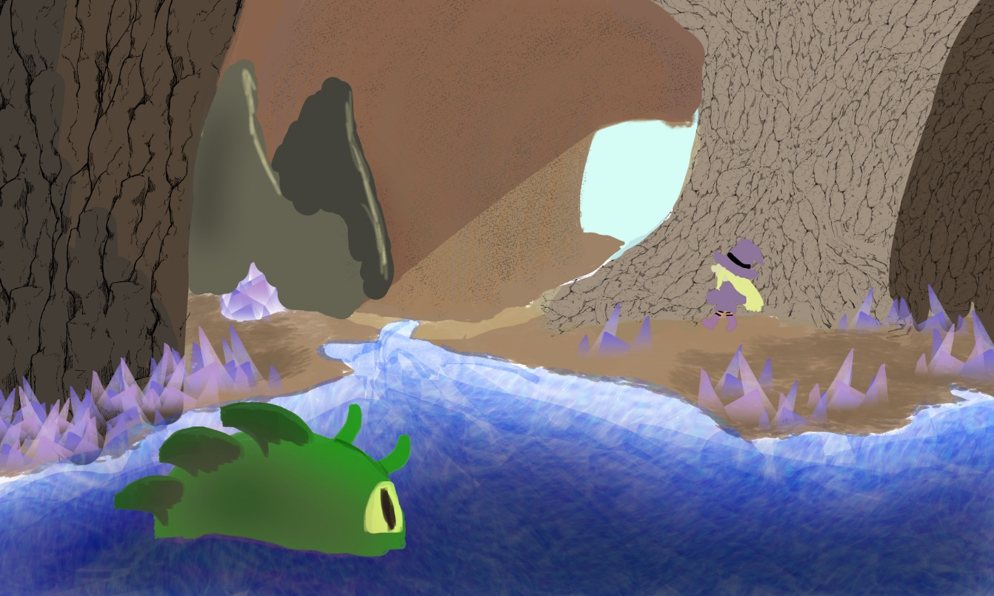

Props
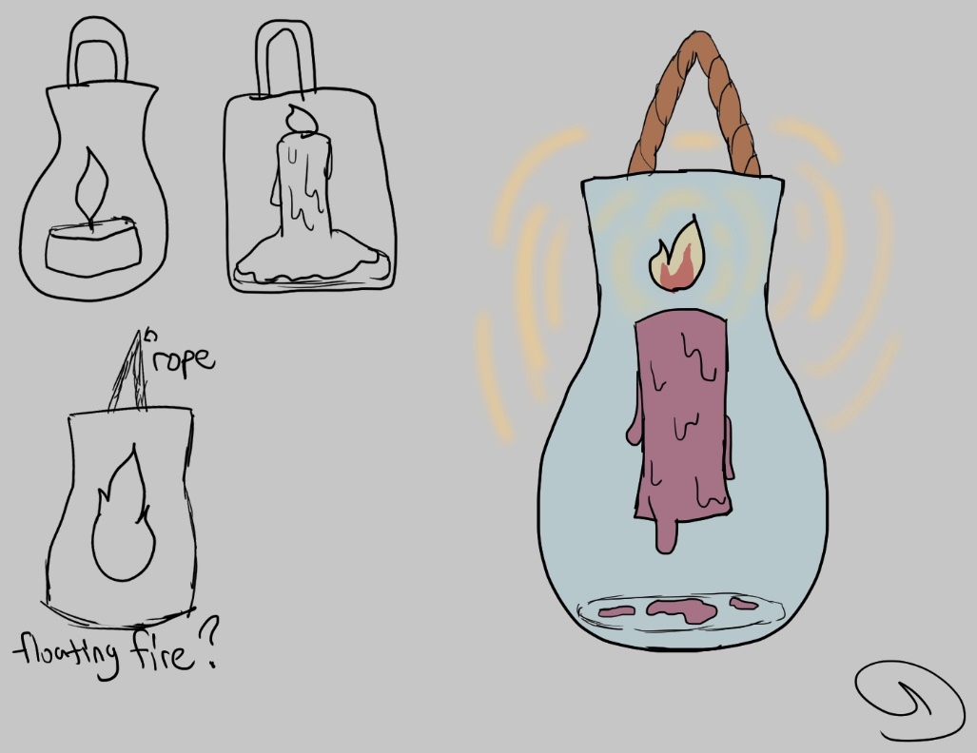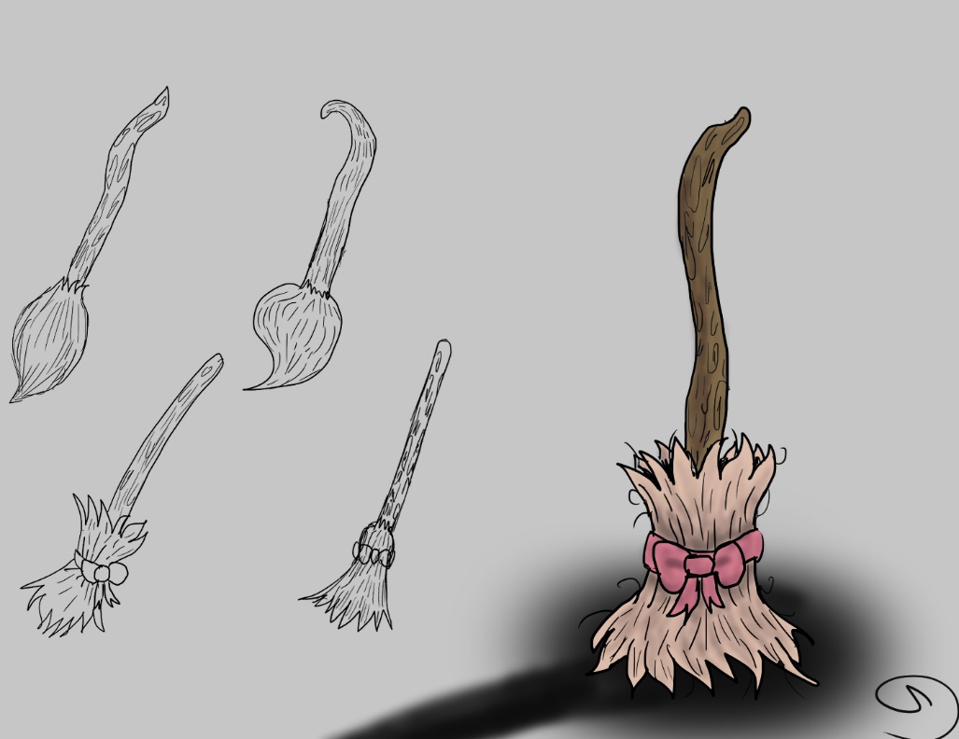
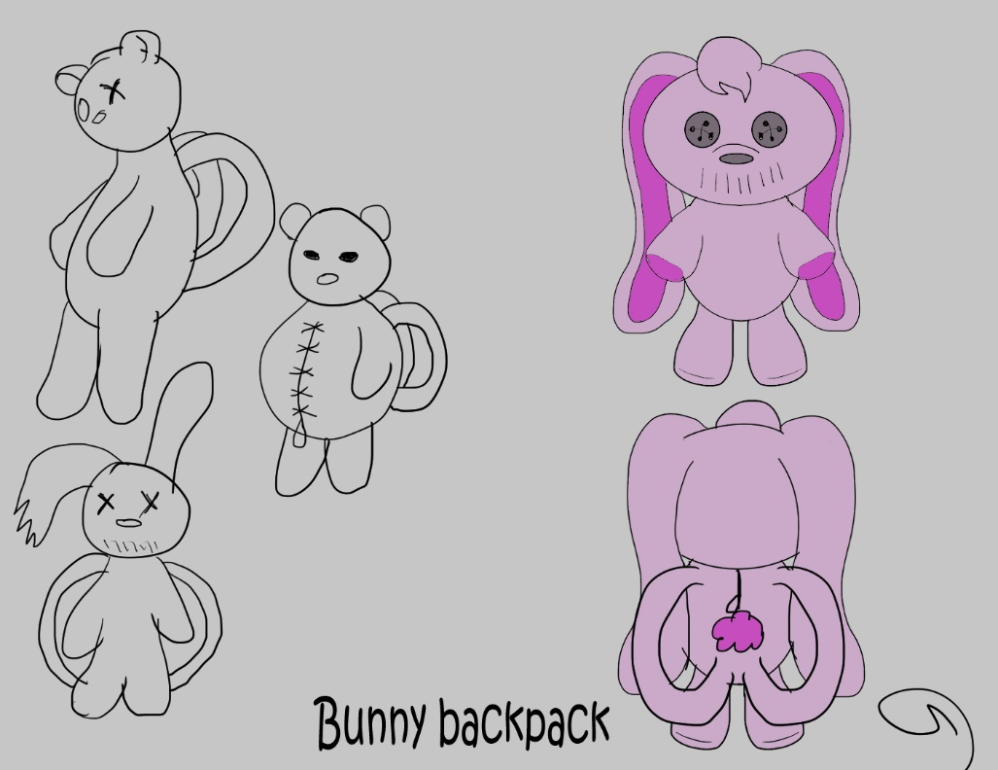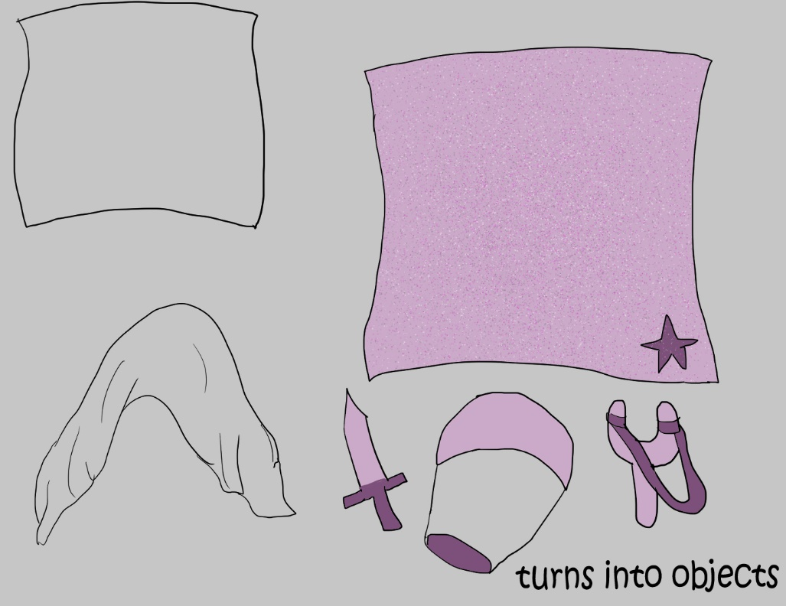

UI Designs
